iTransport User Manual
Oct 6, 2026 · @Ajay kartheek

At a glance
iTransport is Einstein Public School's bus app. It runs in the web browser on any phone or computer, so there is nothing to download. Everyone signs in with a username from the transport office and sees only their own part.
Who | What they see | What they do
Parent | Their child's bus on a map, with an arrival time | Follow the bus, mark trips Absent, get alerts
Driver | Their bus, and who rides from each stop | Slide to start a trip, slide to end it
Transport office | Every bus live, plus all the setup screens | Manage campuses, routes, buses, students and logins
Students ride every school day unless a parent marks a trip Absent. The bus shares its location only between start and end of a trip. Location history is deleted after 30 days.

Getting started
Open iTransport in your phone's browser and sign in with the details the transport office gives you.
- Open itransport-c24mykaktq-el.a.run.app in Chrome (Android) or Safari (iPhone).
- Enter your Username and Password (the temporary one from the office), then tap Sign in.
- The first time, choose your own password of at least 8 characters and tap Save password.
- Add iTransport to your Home Screen so it opens like an app. On iPhone, tap Safari's Share button, then Add to Home Screen. On Android, open Chrome's ⋮ menu, then Add to Home screen.
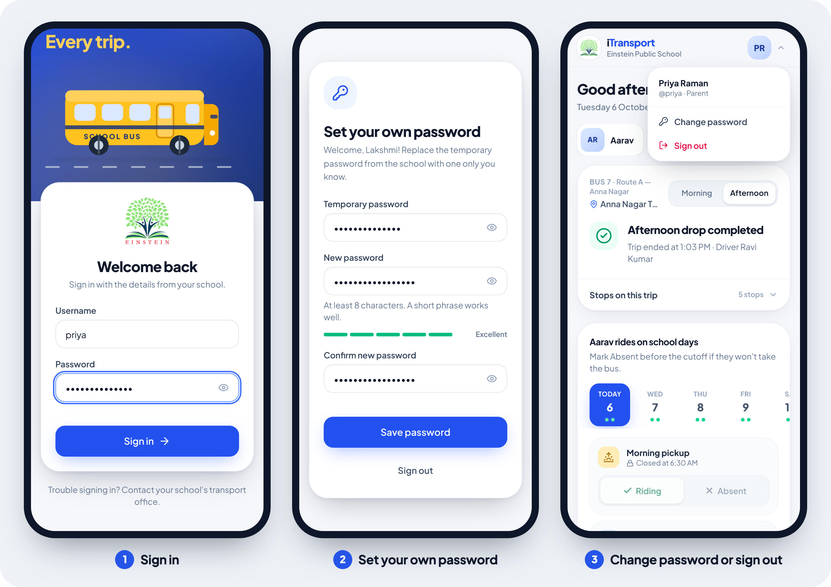
- Change password or sign out: tap your initials at the top right. On the office screens on a computer, your name is at the bottom of the left menu.
- Forgot your password: ask the transport office for a new temporary password.
- Locked out: after 5 wrong passwords in a row, sign-in pauses for 15 minutes. A reset from the office unlocks it at once.
- You stay signed in on that device for 30 days.

Parents
Your home screen shows your child's bus, their stop and when the bus will get there. If you have more than one child, tap a name at the top to switch.
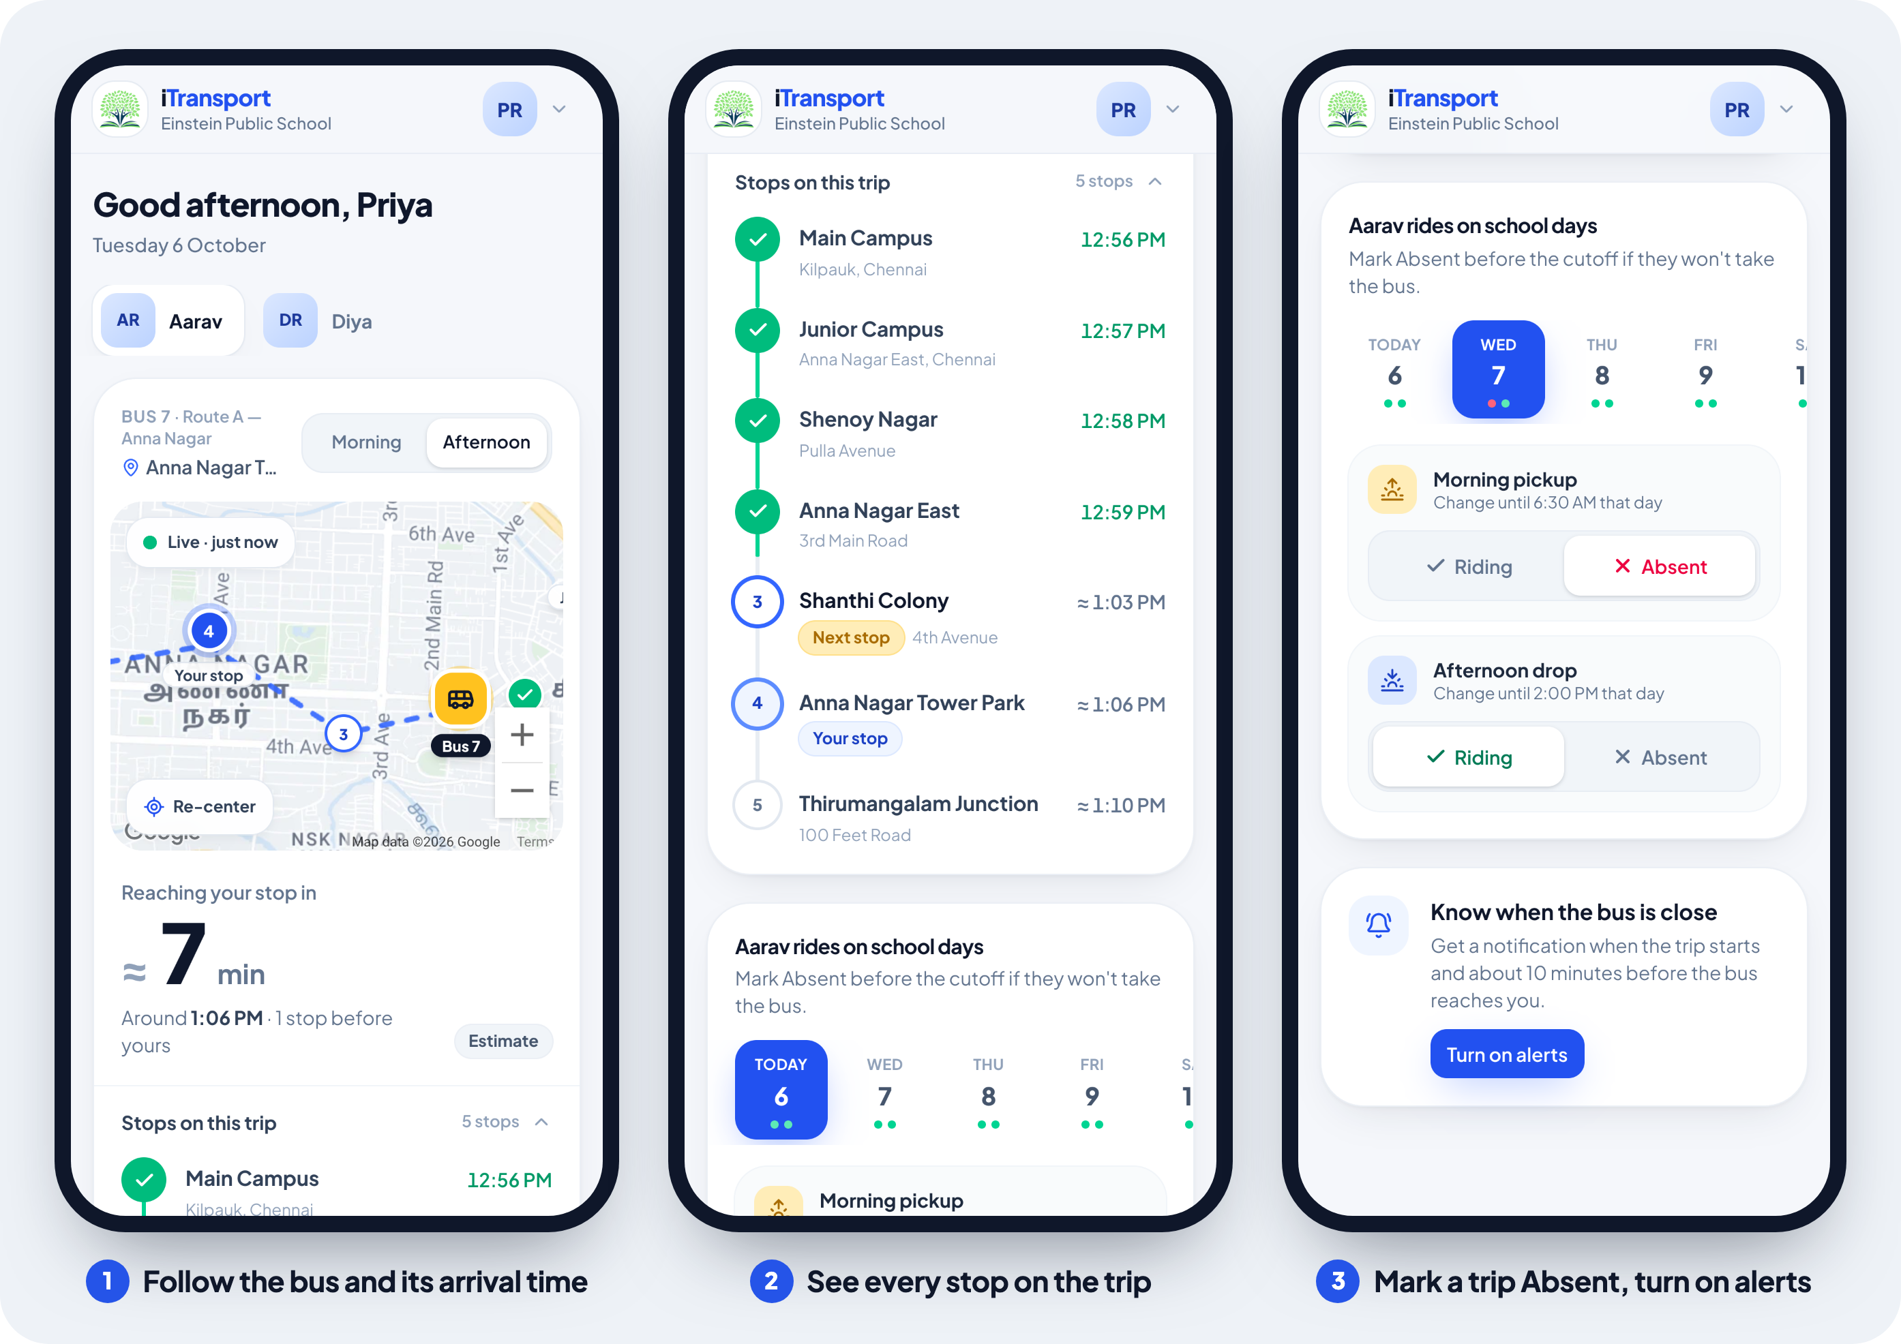

Follow the bus
- The bus card shows the morning trip until noon and the afternoon trip after that. Tap Morning or Afternoon to switch.
- Before the driver starts, the card says the trip hasn't started. After the start, it says the bus is getting ready (or waiting at the campus) until it sets off.
- When the bus is on its way, the map shows it live, marked Live with how fresh the position is. Below it you see Arriving at your stop in 7 min (morning) or Reaching your stop in 7 min (afternoon), the clock time, and how many stops come before yours.
- Then you see The bus is at your stop, followed by Picked up at and Reached Main Campus at in the morning, or Dropped off at in the afternoon.
- Stops on this trip lists every stop. Each one shows a tick and the time once the bus has been there, or Next stop, Your stop, or Passed.

Mark a trip Absent
Your child rides every school day unless you mark a trip Absent.
- In the rides on school days card, tap the day. It shows the next 7 school days.
- Under Morning pickup or Afternoon drop, tap Absent. The driver's list updates straight away.
- To undo it, tap Riding.
Each trip shows its cutoff, such as "Change until 6:30 AM". After the cutoff, or once the bus has left, the trip is locked. If plans change after that, call the transport office.

Turn on alerts
Tap Turn on alerts and allow notifications. On iPhone, first add iTransport to the Home Screen and open it from there; the card shows the steps.
Alert | Sent when
Bus 7 is on its way | The driver starts a morning trip
Bus 7 has started the drop-off | The driver starts an afternoon trip
Bus 7 is about 10 min away | The bus is that close to your stop (the school sets the minutes)
Bus 7 reached Main Campus | A morning bus reaches your child's campus
Tap Send a test to check that alerts arrive. Alerts skip any child marked Absent for that trip.

Drivers
Run each trip from one phone on the bus: start the trip before you set off, keep iTransport open while you drive, and end it after the last stop. Before you leave, put the phone in a mount and on a charger.
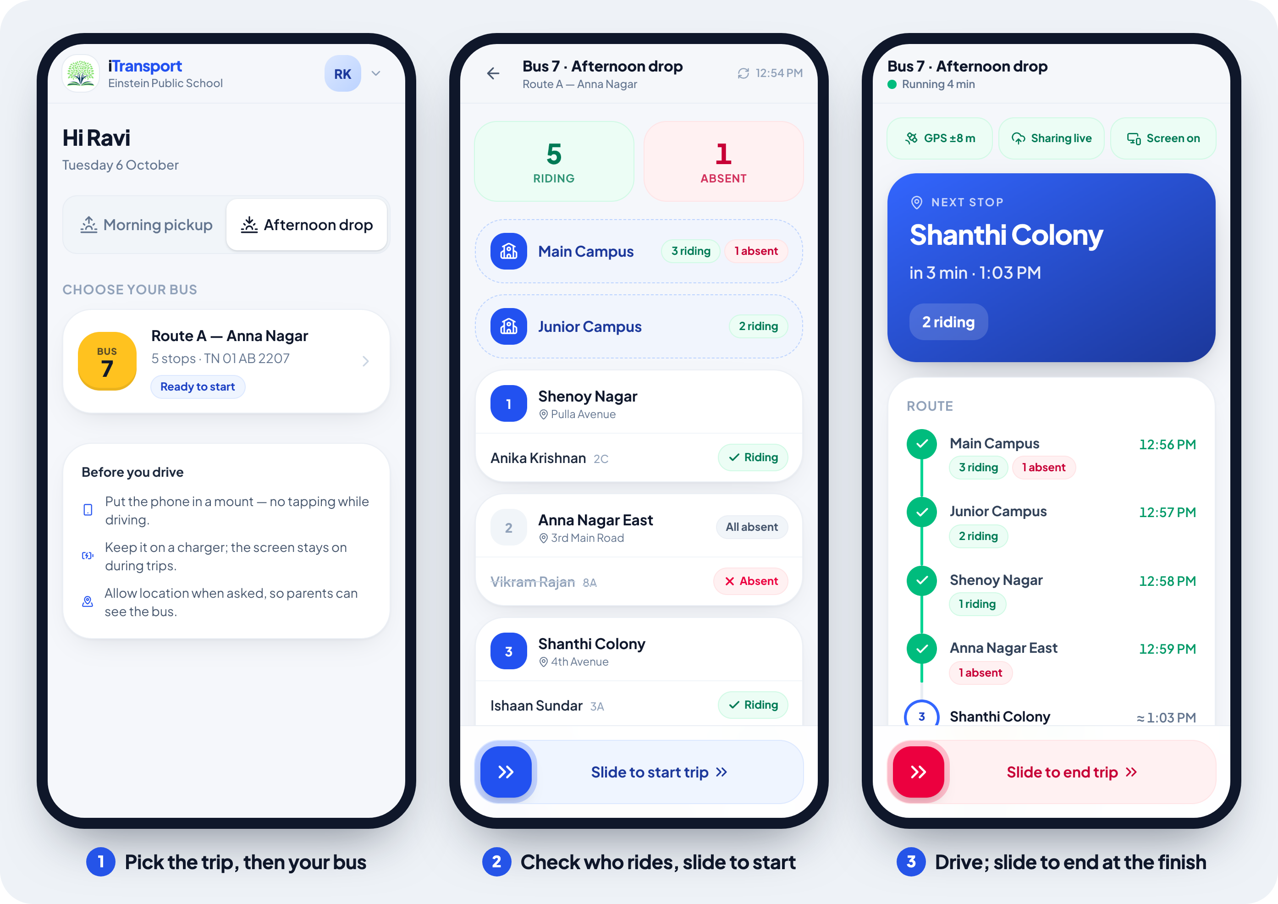
- Choose Morning pickup or Afternoon drop, then tap your bus. It shows Ready to start, You're driving or Completed today.
- Check the list. The Riding and Absent totals are at the top, then each stop with its students. Absent students are crossed out.
- Slide to start trip, and allow location if the phone asks. Parents can now see the bus.
- Drive with iTransport open on screen. The top strip should read GPS ±8 m, Sharing live and Screen on. The big card shows the Next stop, its arrival time and how many students ride there, and turns green with At stop when you arrive. Stops tick off by themselves, so there is nothing to tap.
- After the last stop the card says All stops done. When everyone is off, Slide to end trip. Location sharing stops.
If you leave the page during a trip, open iTransport again and tap the green Trip running card to go back to it.
If you see | Do this
Location is blocked | Allow location for this site in the phone's settings, then reopen the page
Keep this screen open, or Location was paused | Keep iTransport on screen; sharing stops while the phone is locked or another app is open
Weak signal | Nothing; saved updates send by themselves when the signal returns
Your phone's clock looks wrong | Turn on automatic date and time in the phone's settings
The GPS signal is too weak | Keep the phone near the windscreen, with a clear view of the sky
Stop order switched | Nothing; the trip now follows the order you are driving
If a phone can't keep the browser open, the office can set up the free Traccar Client app on it instead (see the office's Buses screen).

Transport office
The office screens work best on a computer. The menu on the left holds them all: Live overview, Trips, Buses, Routes & stops, Students, People & logins, School settings and Activity.

Every day
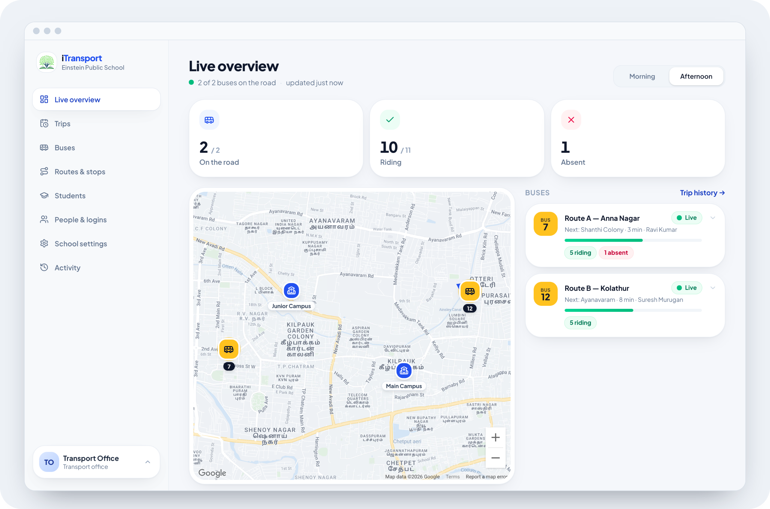
- Live overview shows every bus on one map, with counts for On the road, Riding and Absent. Each bus card shows the next stop, the driver and progress; click a card to see its stops. Signal lost means the bus has sent no location for 2 minutes.
- Trips lists every trip on a chosen date: driver, start and end times, and stops reached. If a driver forgot to end a trip, click End trip on its row.
- Activity lists one day's events: trips, parents' Riding and Absent changes, and office changes. The AI Day summary is written at 8 PM, or click Summarize today so far for an earlier read. The summary never sees student or parent names.
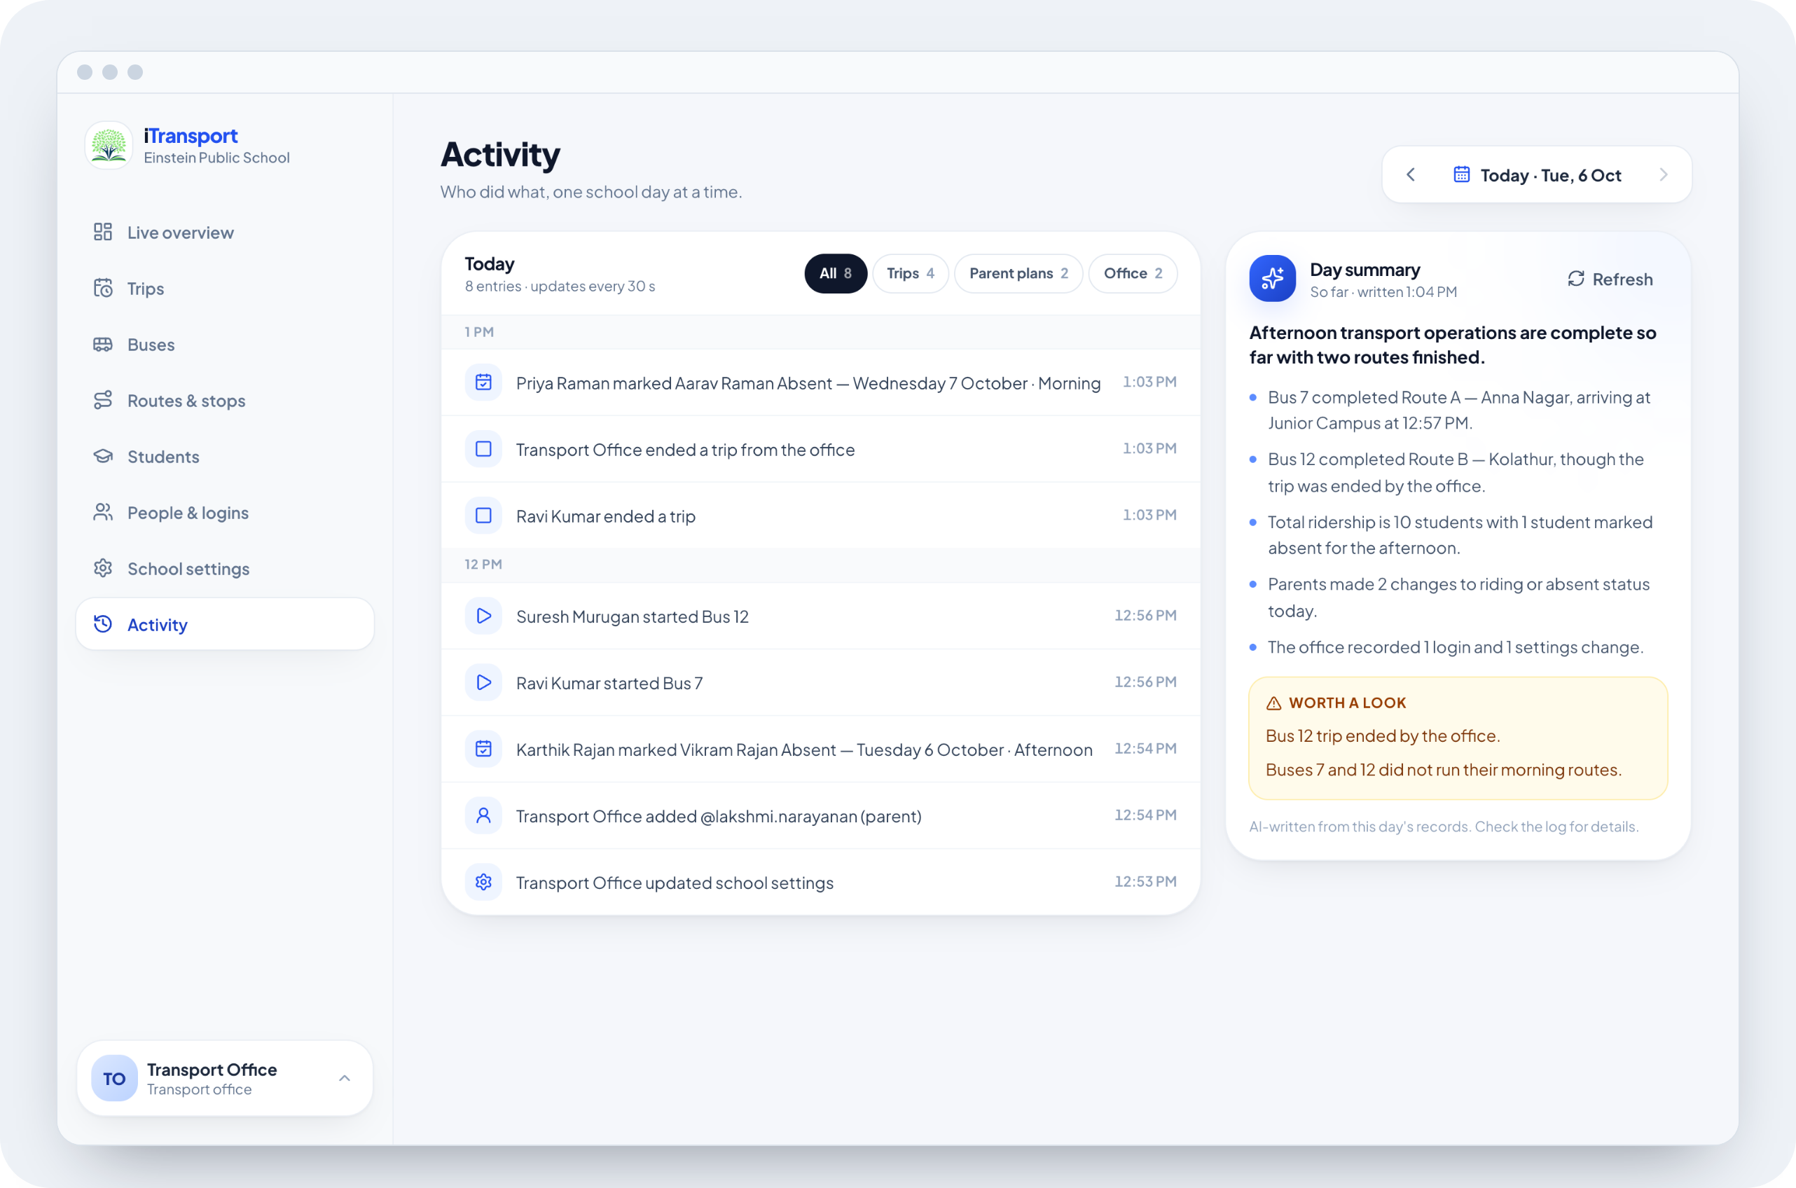

First-time setup
Do these once, in this order. Click any row later to edit it.
- School settings: add each campus by searching for it or clicking the map (up to 4). Set the plan cutoffs, how many minutes ahead parents are alerted, school days and holidays, then click Save changes.
- Routes & stops → New route: name the route, then add stops by searching or clicking the map. Drag the stops into order and pick the campuses the bus goes to. Check Trip order, flip a trip if the bus drives it the other way, and click Create route.
- Buses → Add bus: enter the bus number, plate, seats and route. Drivers can't start a trip until the bus has a route.
- People & logins → Add person: enter the name, role (Parent, Driver or Admin) and mobile. For a driver, pick the buses they drive; picking none lets them drive any bus. Create login shows a temporary password once, so click Copy sign-in details and send them to the person.
- Students → Add student: enter the name and grade, then pick the route, stop, campus and up to 4 parents.
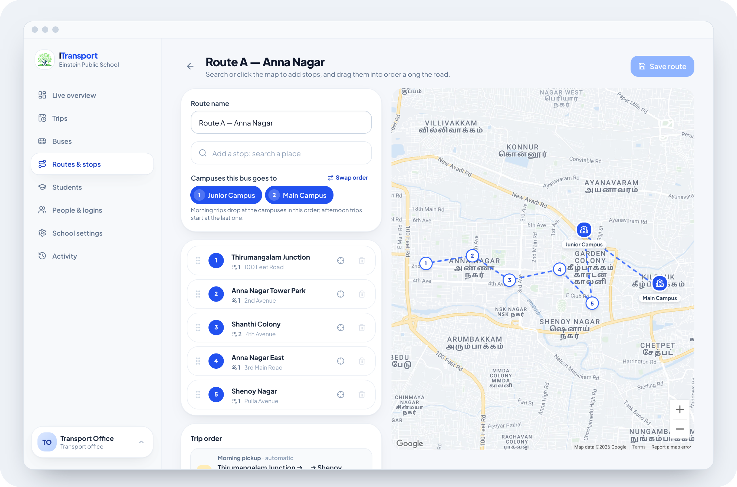

Common tasks
Task | Where
Reset a forgotten password or unlock an account | People & logins → the person → Reset password
Stop a student riding after they leave | Students → the student → turn off Uses the school bus
Add a holiday | School settings → School days & holidays → Add holiday
Take a bus out of service | Buses → the bus → turn off In service
Set up the Traccar Client backup on a bus phone | Buses → the bus → Backup tracker: enter its Server URL and Device identifier in the app, frequency 15 seconds
End a trip a driver forgot | Trips → End trip

Troubleshooting
Most problems show a plain message on screen. Find yours below.
What you see | What it means | What to do
Location paused or Signal lost | The bus hasn't sent its location for 2 minutes, often in a low-signal area | Wait; it updates when the phone reconnects. Drivers: keep iTransport open on screen
≈ and Estimate beside the arrival time | Live traffic data is unavailable, so the time is approximate | Nothing
Waiting for the bus's location… | The trip has started but no location has arrived yet | Wait a minute. Drivers: allow location
The bus has passed your stop | The bus went by without coming close to the stop's pin on the map | If it happens often, ask the office to check the stop's position
No alerts arrive | Alerts are off, or notifications are blocked | Tap Turn on alerts (on iPhone, open iTransport from the Home Screen), then Send a test
Notifications are blocked | The browser blocks iTransport's notifications | Allow notifications for this site in the phone or browser settings
Too many wrong passwords | 5 wrong passwords in a row | Wait 15 minutes, or ask the office to reset the password
A lock and Closed at 6:30 AM under a trip | The cutoff for that trip has passed | Call the transport office
No children linked yet or Not on a bus route yet | The office hasn't linked your child or given them a bus | Contact the transport office
No buses assigned to you (drivers) | The office hasn't assigned you a bus | Ask the transport office

